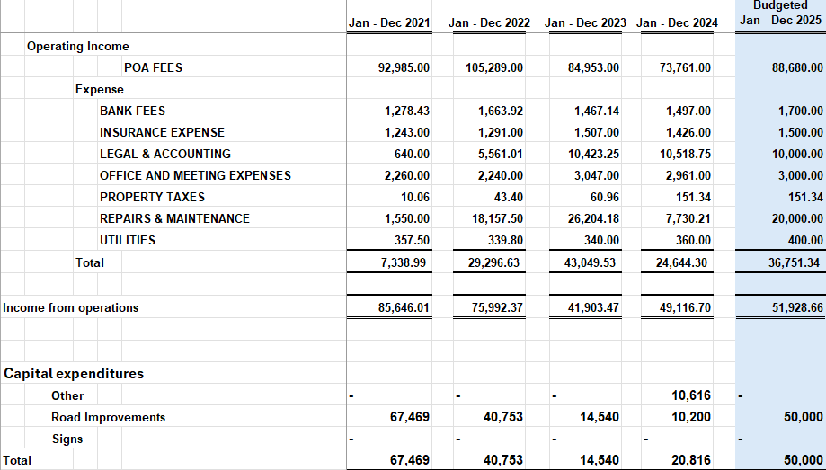
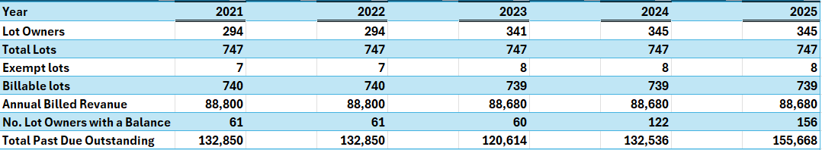
Indian Ridge Subdivision POA BUDGET ACTUAL COSTS 2021-2025

